**TITLE - Assessing Awareness and Engagement in Society : Focus on**

**Mayur Phase 1**

**(MINOR PROJECT-1) BBA-116**

**Submitted in Partial Fulfilment for the Award of the Degree of Bachelor in Business Administration, 2024-2028**



**Under the guidance of: Submitted by :**

**Dr. Swaralipi Saha Aarush Vaish**

**57491201724**



**DELHI METROPOLITAN EDUCATION**

**Affiliated to Guru Gobind Singh Indraprastha University, Delhi**

**12B, Sector -62, Noida - 201014**

**DECLARATION BY THE STUDENT**

I undersigned solemnly declare that the minor project-1 report Assesing awareness and engagement in society; focus on mayor phase 1is based on my individual work carried out throughout the course of our study under the supervision of **Dr Swaralipi Saha**. I declare the statements made and conclusions drawn are the result of my research work. I further certify that

1. The work contained in the report is original and has been done by me under the general supervision of my supervisor.
2. The work has not been submitted to any other Institution for any other degree/diploma/certificate in this university or any other University of India or abroad.
3. We have followed the guidelines provided by the university in writing the report.
4. Whenever we have used materials (data, theoretical analysis, and text) from other sources, we have given due credit to them in the text of the report and giving their details in the references.

**Signature:**

**Name:** Aarush Vaish

**Enrollment No.:** 57491201724

**College Name:** DELHI METROPOLITAN EDUCATION

**SUPERVISOR’S CERTIFICATE**

This is to certify that the Minor Project-1 report and Viva Voce submitted in partial fulfilment of the Bachelor of Business Administration (BBA) degree to be awarded by **G.G.S.I.P. University, Delhi** by **Aarush Vaish**, Enrollment No. **57491201724**, has been completed under my guidance and is satisfactory.

**Date:**

**Signature of the Guide:**

**Name of the Guide:** Dr. Swaralipi Saha

**Designation:** Professor

**TABLE OF CONTENTS**

**CHAPTER 1 INTRODUCTION………………………….……….……..5**

**LITERATURE REVIEW…………………………………………………8**

**CHAPTER 2 OBJECTIVES OF THE STUDY………………..….……11**

**CHAPTER 3 RESEARCH METHODOLOGY………………………..13**

**CHAPTER 4 DATA ANALYSIS AND FINDINGS……………………..16**

**CHAPTER 5 CONCLUSION & RECOMMENDATIONS……..……..24**

**CHAPTER 6 LIMITATIONS……………………………………………27**

**APPENDIX……………………………………………………………….28**

**QUESTIONNAIRE………………………………………………………28**

**CHAPTER 1  
(INTRODUCTION)**

**INTRODUCTION**

***A Study on*** Assesing awareness and engagement in society; focus on mayor phase 1

In today’s rapidly urbanizing world, the concept of sustainability has become a cornerstone of responsible development. As global populations rise and more people move into cities, the importance of building communities that are both livable and sustainable has taken center stage. Among the most practical and impactful levels at which sustainability can be implemented is the neighbourhood. A sustainable neighbourhood represents more than just eco-friendly housing or green energy; it embodies a holistic system where environmental protection, social equity, and economic resilience converge to create spaces that support both people and the planet.

A neighbourhood is the basic unit of urban and suburban life—a place where people live, work, socialize, raise families, and interact with their environment daily. Because of this, it serves as the ideal scale for implementing sustainable practices that have real and measurable impacts. Unlike broader national or global sustainability initiatives, neighbourhood-level changes can be more tailored to local needs, cultures, and resources. These changes often involve the integration of green infrastructure, low-impact transportation systems, efficient energy use, waste management, and strong community engagement. When successfully implemented, they not only reduce environmental footprints but also improve quality of life and foster social cohesion.

### **The Pillars of Neighbourhood Sustainability**

Sustainability in neighbourhoods is generally grounded in three main pillars: environmental integrity, social equity, and economic viability. These pillars work together to ensure that development does not compromise the wellbeing of future generations.

**1. Environmental Sustainability**  
At its core, environmental sustainability in neighbourhoods aims to reduce ecological footprints and promote the responsible use of natural resources. This includes the construction of energy-efficient buildings, use of renewable energy sources like solar or wind power, effective water management systems, and widespread recycling and composting initiatives. Moreover, green spaces such as parks, community gardens, and tree-lined streets play a crucial role in maintaining biodiversity, improving air quality, and offering residents places for recreation and relaxation.

Sustainable neighbourhoods are also designed with climate resilience in mind. They incorporate features like permeable pavements to reduce stormwater runoff, buildings that can withstand extreme weather events, and landscaping that conserves water. Urban heat island effects—where concrete and asphalt trap heat—are mitigated through the planting of vegetation and the use of reflective materials.

**2. Social Sustainability**  
A truly sustainable neighbourhood doesn’t only focus on the environment—it also prioritizes the wellbeing and inclusion of its residents. Social sustainability is about creating communities where everyone has access to basic services, feels a sense of belonging, and can participate in decision-making. This means designing public spaces that are safe and welcoming, ensuring access to affordable housing, and supporting diverse populations through inclusive planning.

Cultural vibrancy, education, healthcare, and opportunities for civic engagement are essential components. A socially sustainable neighbourhood nurtures trust among residents, facilitates community-building activities, and provides platforms for voices to be heard, particularly those of marginalized groups.

**3. Economic Sustainability**  
For neighbourhood sustainability to be effective and long-lasting, it must also be economically viable. Economic sustainability involves supporting local economies, creating jobs, and ensuring that the cost of sustainable living is affordable for a wide range of income levels. Local businesses, farmers markets, and co-working spaces are key elements of an economically resilient neighbourhood.

Furthermore, economic sustainability is linked to long-term investment in infrastructure that yields cost savings over time, such as energy-efficient buildings or public transport systems. It also entails policies that encourage sustainable business practices and fair access to employment and financial services.

**Significance of the Study**

The significance of this study is important for many different groups of people, such as lawmakers, city planners, environmental groups, and community leaders. This study will provide valuable information that can help them understand how much people know about environmental issues and how involved they are in activities that support sustainability. By identifying areas where people may lack understanding or are not actively participating, the study can help in creating educational programs that focus on these specific issues. These programs can be designed in a way that is easy to understand and meaningful for the people they are meant to help.

For local governments, the study’s findings can be used to design sustainability programs that are more inclusive and easier for everyone to take part in, especially those from communities that may have fewer resources or face other challenges. The information can help them ensure that their programs are fair and meet the needs of all residents.

**LITERATURE REVIEW**

The concept of sustainability in neighbourhoods has gained increasing attention in urban planning, architecture, and policy-making over the past two decades. The literature spans interdisciplinary fields and focuses on the integration of environmental, social, and economic considerations at the local level. This review synthesizes key findings, theoretical frameworks, and case studies that explore the principles, challenges, and implementations of sustainability within neighbourhoods.

### **1. Defining Sustainable Neighbourhoods**

The foundational literature on sustainable urbanism (Beatley & Newman, 2009; Farr, 2008) frames neighbourhoods as crucial sites for implementing sustainability. According to the United Nations' sustainable development framework, neighbourhood-level sustainability is vital for achieving broader city-wide and national environmental goals (UN-Habitat, 2020). A sustainable neighbourhood is typically defined as one that minimizes environmental impact, promotes social cohesion and equity, and fosters economic resilience (Barton, Grant & Guise, 2010).

### **2. Theoretical Frameworks**

Several frameworks have been proposed to assess and guide sustainability at the neighbourhood level:

* **The Triple Bottom Line (Elkington, 1997)** emphasizes balancing environmental, social, and economic outcomes.
* **One Planet Living Principles** developed by Bioregional and WWF highlight factors like zero carbon, sustainable transport, and local economy.
* **LEED for Neighborhood Development (LEED-ND)** and **BREEAM Communities** provide certifications and metrics for evaluating sustainable practices in community design (USGBC, 2011).

These frameworks offer structured approaches but often require adaptation to local contexts, especially in the Global South where informal settlements may lack infrastructure and regulatory frameworks (Watson, 2009).

### **3. Environmental Dimensions**

A major body of literature focuses on reducing environmental impact through design and technology. Topics include:

* **Green infrastructure and urban form:** Studies show that compact, walkable neighbourhoods with mixed land use reduce emissions and promote healthier lifestyles (Ewing & Cervero, 2010).
* **Energy efficiency and renewable resources:** Research supports the integration of passive solar design, renewable energy systems, and energy retrofitting in residential buildings (Droege, 2006).
* **Water and waste systems:** Decentralized water systems and circular waste management approaches, such as in Hammarby Sjöstad (Sweden), demonstrate successful models for sustainability (Pandis Iveroth et al., 2013).

### **4. Social Sustainability and Community Engagement**

Social sustainability remains a complex and sometimes underexplored area. Bramley et al. (2009) argue that socially sustainable neighbourhoods must offer housing diversity, safety, public spaces, and social inclusion. Literature also emphasizes the importance of community participation in planning and governance, which increases acceptance of sustainable initiatives (Forester, 1999; Healey, 2006).

The challenge of gentrification is a recurring theme. While environmental improvements can increase property values and attract investment, they also risk displacing long-term, lower-income residents (Checker, 2011).

**CHAPTER 2  
(OBJECTIVES)**

**OBJECTIVES**

• THE 5 MAJOR OBJECTIVES OR KEY PILLARS OF SUSTAINABILITY IN NEIGHBOURHOOD:

### 1. **Environmental Protection and Resource Efficiency**

* **Objective:** Minimize the environmental impact of neighbourhoods by reducing carbon emissions, conserving energy and water, managing waste sustainably, and protecting biodiversity.
* **Actions:** Implement green building practices, promote renewable energy, enhance green spaces, and support low-impact transportation options like walking, cycling, and public transit.

### 2. **Social Inclusion and Community Wellbeing**

* **Objective:** Foster an inclusive, healthy, and cohesive community where all residents have access to basic services, feel safe, and can actively participate in neighbourhood life.
* **Actions:** Ensure affordable housing, accessible public spaces, community engagement, social equity, and local cultural support.

### 3. **Economic Vitality and Local Resilience**

* **Objective:** Support a strong, diverse local economy that provides employment opportunities, encourages small businesses, and ensures long-term affordability for residents.
* **Actions:** Promote local enterprises, integrate mixed-use development, and invest in green jobs and infrastructure.

### 4. **Efficient and Integrated Urban Planning**

* **Objective:** Design neighbourhoods that are compact, connected, and multifunctional to reduce sprawl and enhance livability.
* **Actions:** Embrace mixed-use zoning, walkable street layouts, sustainable mobility options, and smart infrastructure.

### 5. **Climate Resilience and Adaptability**

* **Objective:** Prepare neighbourhoods to withstand and adapt to climate-related risks such as heatwaves, flooding, and extreme weather.
* **Actions:** Implement nature-based solutions, build climate-resilient infrastructure, and develop community emergency response plans.

**CHAPTER 3  
(RESEARCH**

**METHODOLOGY)**

**RESEARCH METHODOLOGY**

### **Sampling Techniques**

For this study, the **convenience sampling** method was chosen as the most suitable approach. This involved gathering information from individuals who were easily accessible and willing to participate—such as local residents, neighbors, friends, or people at nearby community centers and parks.

**Why Convenience Sampling?**

1. **Time and cost efficiency** – Participants were easy to find, which eliminated the need for a lengthy or costly selection process.
2. **Quicker research initiation** – Engaging with nearby individuals allowed us to begin data collection on local sustainability practices promptly.
3. **Practicality** – Since the research focused on neighborhoods, it was logical and efficient to involve individuals from the local area who are directly impacted by sustainability-related issues.

### **Questionnaire Development**

The questionnaire was developed in alignment with the study’s objectives and validated by subject matter experts. It consists of **15 questions**, addressing the following key areas:

1. Basic demographic information (e.g., age, gender)
2. Awareness and understanding of sustainability
3. Actions and behaviors related to sustainable living
4. Challenges encountered and suggestions for improvement

A combination of **closed-ended** (multiple choice or yes/no) and **open-ended** questions was used to ensure both quantitative data and in-depth qualitative insights could be gathered.

### **Data Collection Process**

To evaluate the level of awareness and involvement in sustainability practices, **face-to-face interviews** were conducted. These took place in **Una Enclave**, located in **Mayur Vihar Phase-1**—a middle-class residential area characterized by average infrastructure and diverse engagement with sustainability issues.

### **In-Depth Interviews**

A total of **10 residents** were selected for in-depth interviews, representing a mix of backgrounds such as working professionals, students, and homemakers. This ensured a variety of perspectives and experiences were captured in the study.

**CHAPTER 4**

**(DATA ANALYSIS**

**AND FINDINGS)**

**DATA ANALYSIS AND FINDINGS**

### **What We Discovered**

Our research uncovered valuable insights into the levels of sustainability awareness and engagement across various neighbourhoods.

### **Key Findings**

1. **Awareness Levels Differ:** Residents’ awareness of sustainability initiatives varies significantly from one neighbourhood to another.
2. **Engagement Drives Impact:** Neighbourhoods with higher levels of community engagement tend to have residents who are more environmentally conscious and proactive.
3. **Community Connection Matters:** A strong sense of community correlates with increased participation in sustainability efforts.

### **Resident Perspectives**

1. **Eager to Learn:** Many residents expressed interest in gaining more knowledge about sustainability and how they can contribute meaningfully.
2. **Participation Barriers:** Common challenges to engagement include limited time, lack of resources, and insufficient access to information.

### **Implications for Action**

1. **Focused Education Efforts:** Tailored awareness campaigns and educational programs can help bridge knowledge gaps and boost engagement.
2. **Community-Driven Approaches:** Initiatives led by the community can foster a greater sense of ownership and encourage more active resident participation.

By recognizing and responding to the unique needs and views of residents, we can design more effective strategies to advance sustainability at the neighbourhood level

**Graphical Representations**

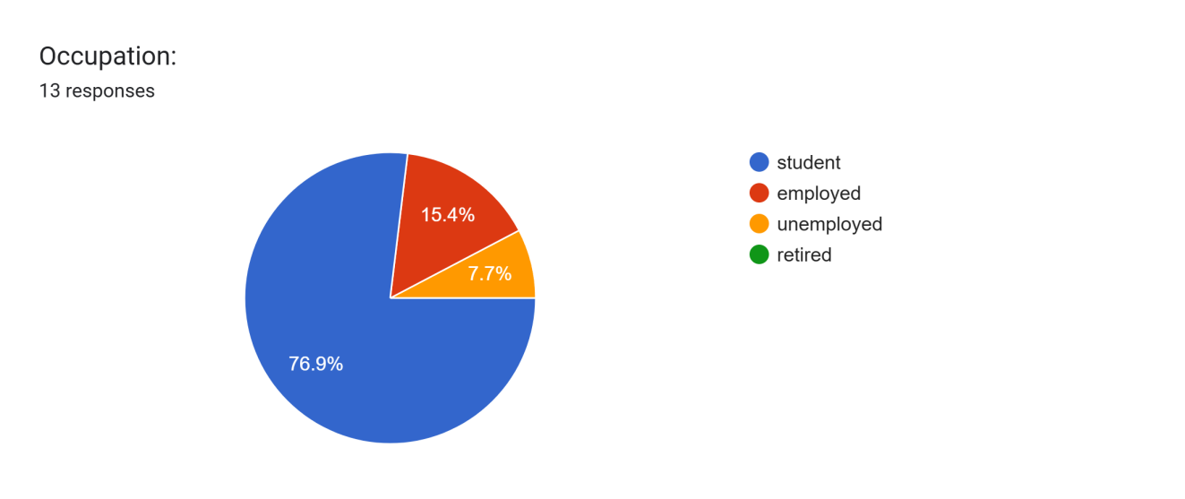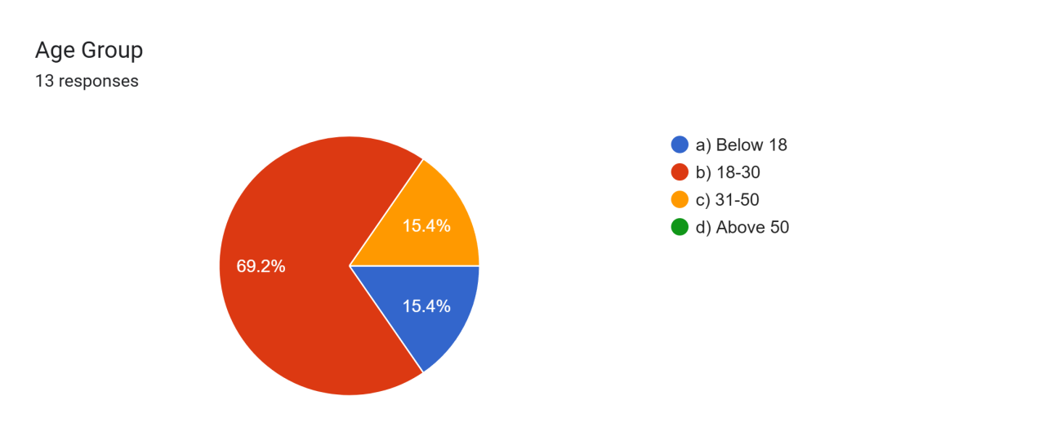

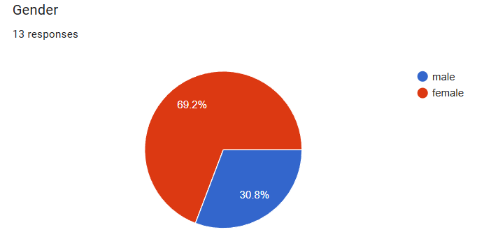

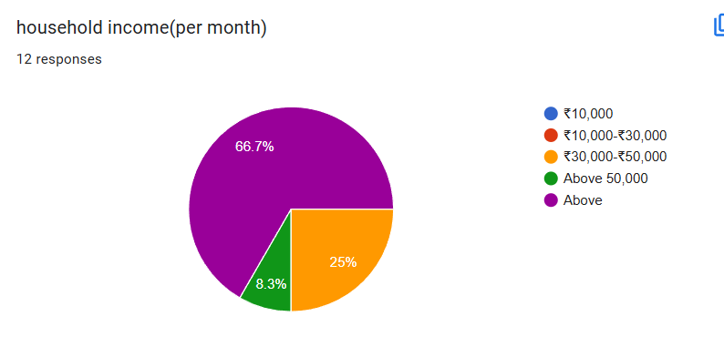

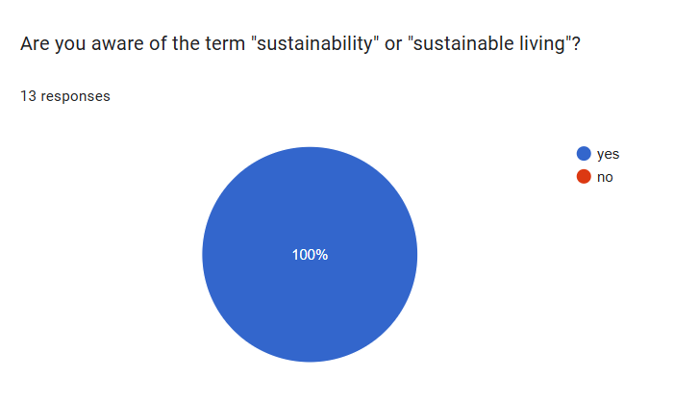



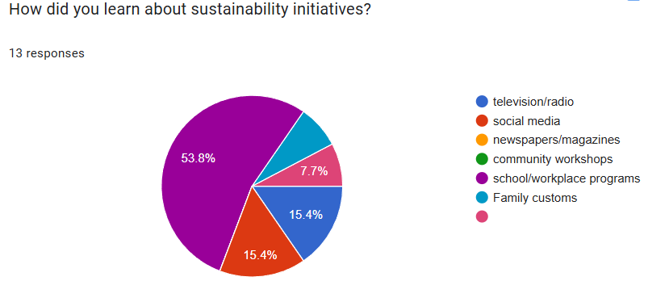

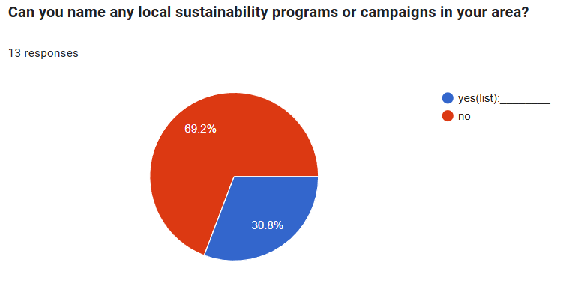

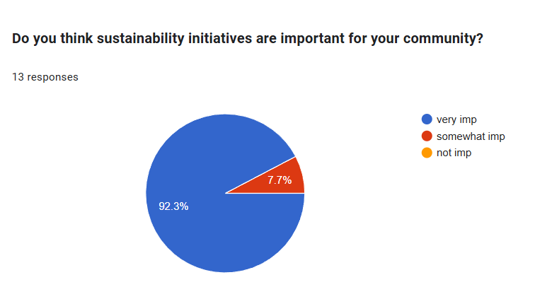

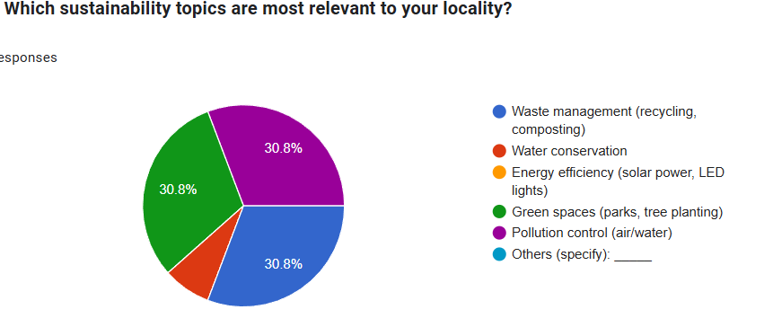

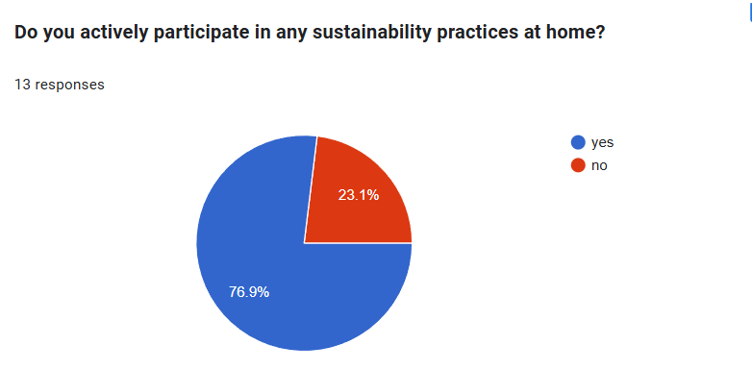

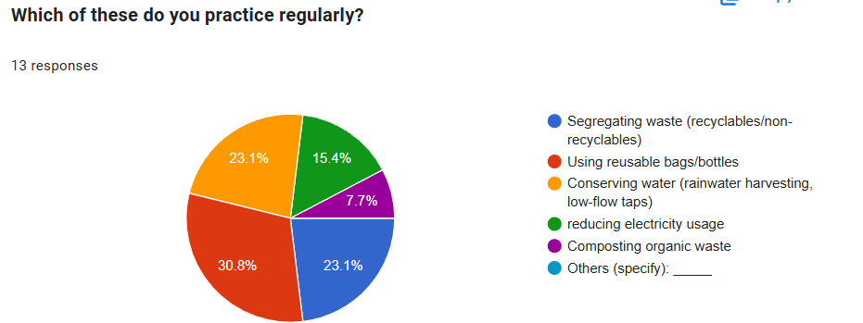

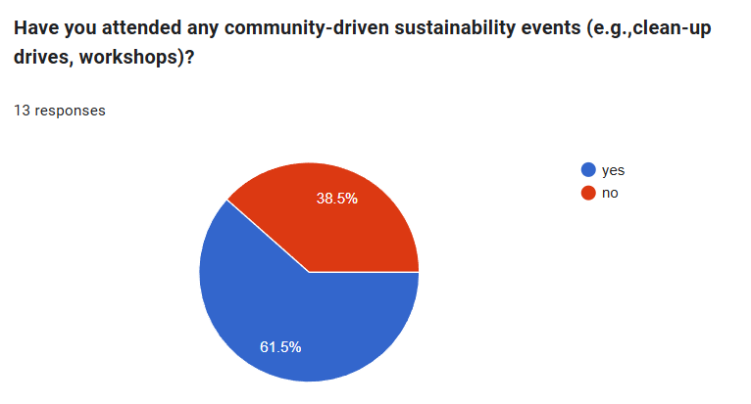

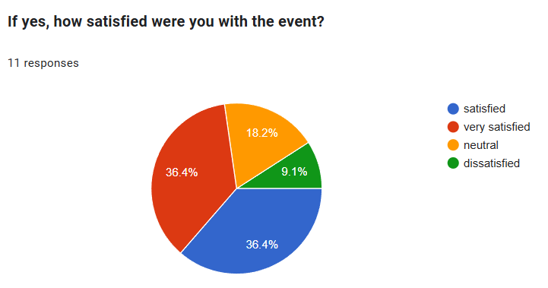

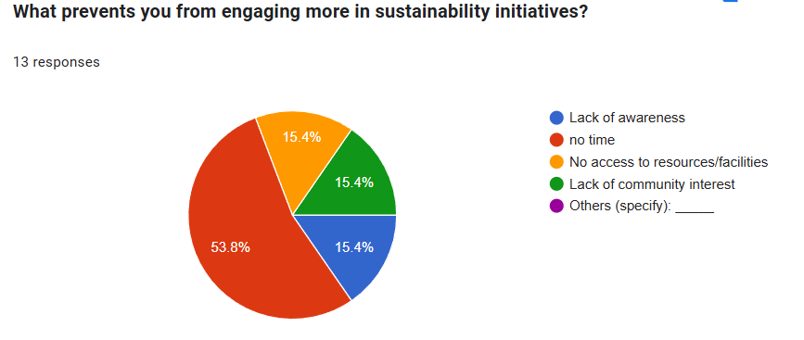

**CHAPTER 5**

**(CONCLUSION &RECOMMENDATIONS)**

**CONCLUSION & RECOMMENDATIONS**

### **Putting Sustainability into Practice**

1. **Community Gardens:** Bringing residents together to cultivate community gardens encourages local food production and strengthens neighborhood bonds.
2. **Green Spaces:** Developing and preserving parks and green areas helps combat urban pollution, boosts air quality, and supports local ecosystems.
3. **Waste Reduction:** Effective recycling and waste reduction programs can greatly minimize the environmental footprint of urban neighbourhoods.

### **Why Sustainability Matters**

1. **A Healthier Environment:** Sustainable practices contribute to cleaner air, water, and soil—leading to improved public health and overall well-being.
2. **Connected Communities:** When communities lead sustainability efforts, it nurtures stronger social ties and a shared sense of purpose.
3. **Economic Advantages:** Sustainability can drive down utility costs, promote energy efficiency, and generate employment through green jobs and industries.

### **Moving Forward**

1. **Increase Awareness:** Continue educating residents about sustainability and the positive impact it has on both people and the planet.
2. **Encourage Participation:** Actively involve community members in sustainability efforts to build momentum and collective ownership.
3. **Track and Improve:** Regularly assess the effectiveness of initiatives and refine strategies to ensure lasting progress.

By coming together and taking action, we can build neighbourhoods that are not only more sustainable, but also more vibrant, connected, and resilient.

**CHAPTER 6**

**(LIMITATIONS )**

**LIMITATIONS**

### **Challenges Encountered**

1. **Time Limitations:** Researching across multiple neighbourhoods demands substantial time and resources, presenting a significant challenge.
2. **Diverse Responses:** The wide variation in residents' responses made it difficult to draw clear, consistent conclusions.

### **Opportunities for Improvement**

1. **Broader Representation:** Including a more diverse range of neighbourhoods could enhance our understanding of sustainability awareness and engagement across different demographics.
2. **Long-Term Research:** A longitudinal study would allow us to track how sustainability awareness and involvement evolve over time.

### **Key Takeaways**

1. **Adaptability:** Flexibility and adaptability are essential when conducting research in varied neighbourhoods with unique characteristics.
2. **Building Relationships:** Establishing strong connections with community members is vital for ensuring successful and meaningful research.

By recognizing these challenges and areas for growth, we can refine our methods and enhance future studies on sustainability in neighbourhoods.

**APPENDIX**

Residents sharing their perspective on sustainability:

**QUESTIONNAIRE**

1. **Age Group:**

a) Below 18

b) 18-30

c) 31-50

d) Above 50

**2. Gender:**

a) Male

b) Female

c) Other

**3. Occupation:**

a) Student

b) Employed

c) Unemployed

d) Retired

**4. Locality Type:**

a) Rural

b) Semi-urban

c) Urban

**5. Household Income:**

a) Below ₹10,000

b) ₹10,000-₹30,000

c) ₹30,000-₹50,000

d) Above ₹50,000

**6. Are you aware of the term "sustainability" or "sustainable living"?**

a) Yes

b) No

**7. How did you learn about sustainability initiatives? (Multiple answers**

**allowed)**

a) Television/Radio

b) Social media

c) Newspapers/Magazines

d) Community workshops

e) School/Workplace programs

f) Others (specify): _____

**8. Can you name any local sustainability programs or campaigns in your**

**area?**

a) Yes (list): _____

b) No

**9. Do you think sustainability initiatives are important for your**

**community?**

a) Very important

b) Somewhat important

c) Not important

1. **Which sustainability topics are most relevant to your locality? (Multiple answers allowed)**

a) Waste management (recycling, composting)

b) Water conservation

c) Energy efficiency (solar power, LED lights)

d) Green spaces (parks, tree planting)

e) Pollution control (air/water)

f) Others (specify): _____

**11. Do you actively participate in any sustainability practices at home?**

a) Yes (list): _____

b) No

**12. Which of these do you practice regularly? (Multiple answers allowed)**

a) Segregating waste (recyclables/non-recyclables)

b) Using reusable bags/bottles

c) Conserving water (rainwater harvesting, low-flow taps)

d) Reducing electricity usage

e) Composting organic waste

f) Others (specify): _____

**13. Have you attended any community-driven sustainability events (e.g.,**

**clean-up drives, workshops)?**

a) Yes

b) No

**14. If yes, how satisfied were you with the event?**

a) Very satisfied

b) Satisfied

c) Neutral

d) Dissatisfied

**15. What prevents you from engaging more in sustainability initiatives?**

a) Lack of awareness

b) No time

c) No access to resources/facilities

d) Lack of community interest

e) Others (specify): _____